Final Project Report: BMW Worldwide Sales (2010-2024) Analysis

1. Project Objective & Data
This report details the findings from an exploratory data analysis (EDA) on the "BMW Worldwide Sales Records (2010-2024)" dataset sourced from Kaggle. The primary goal was to acquire, clean, and analyze this data to extract valuable business insights and provide actionable recommendations, in line with the project objectives. The analysis was conducted using Python with the Pandas, Seaborn, Matplotlib, and SciPy libraries.

2. Data Cleaning
Before analysis, the dataset of 50,000 records was rigorously cleaned to ensure accuracy and reliability.
- Missing Values: A check for null values showed that the dataset was complete, with zero missing (null) values found.
- Duplicates: The dataset contained zero duplicate rows.
- Outlier Handling: An iterative outlier removal process using the 1.5x IQR (Interquartile Range) rule was applied to the four primary numerical columns: Price_USD, Sales_Volume, Mileage_KM, and Engine_Size_L. This process confirmed that the data was well-contained, as no statistical outliers were detected or removed in this dataset.
The final cleaned dataset was used for all subsequent analyses.

3. Data Visualization & Analysis
The core of the EDA involved creating several visualizations to understand the data.
Graph 1: Boxplot - Volume of Sales by Model
- What it Shows: This boxplot displays the full distribution (median, quartiles, and range) of sales volume for each BMW model.
- Justification: A boxplot was chosen over a standard bar chart because it provides a more conveyable statistical summary. Instead of just showing a mean or sum, it directly reveals the differences in sales spread, median sales, and variation between models, which is essential for understanding business dynamism.
- Finding: There is a significant variation in sales performance between models, with some models having a much wider range of sales volumes than others.

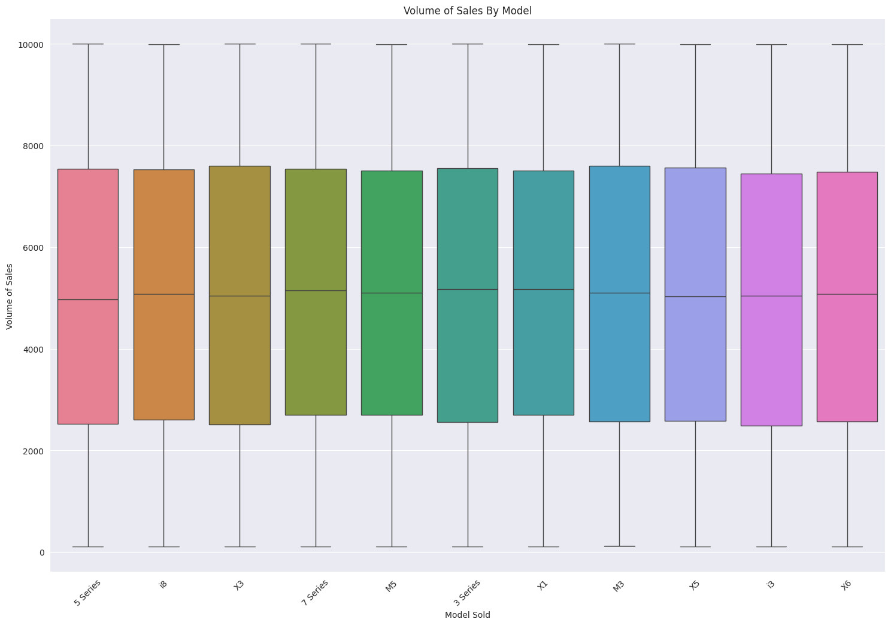

Graph 2: Countplot - Fuel_Type vs Transmission
- What it Shows: This plot counts the total number of vehicles for each Fuel_Type and uses stacked colors to show the breakout between Automatic and Manual transmissions.
- Justification: A countplot is ideal for showing the frequency of each category. This visualization was used to compare the distribution of transmission types across different fuel types.
- Finding: This chart visually shows the relative popularity of transmission types within each fuel category. We observed that these are statistically independent.

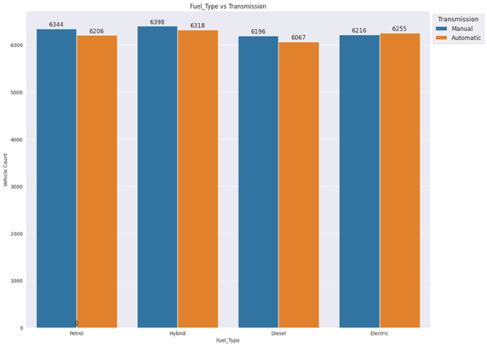
Graph 3: Bar Chart - Sales Records Distribution by Region
- What it Shows: This is a horizontal bar chart that displays the total count of sales records for each geographical region.
- Justification: A bar plot was used to provide a clear, direct comparison of which regions have the highest number of sales records.
- Finding: The chart clearly shows the regions with the highest and lowest sales volumes in the dataset.

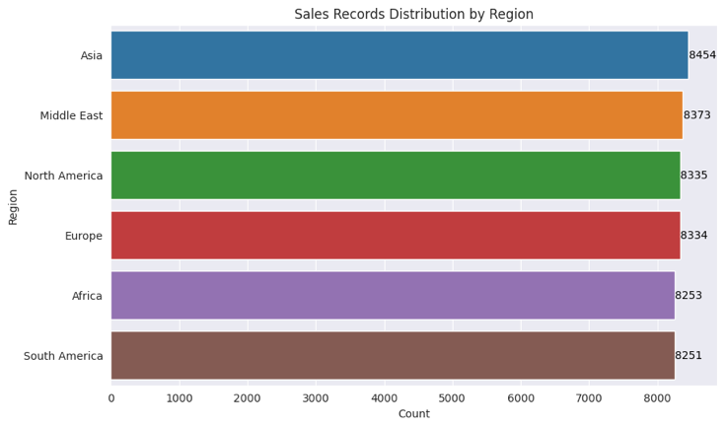

Graph 4: Boxplot - Price Distribution by Region
- What it Shows: This boxplot compares the distribution of vehicle prices (Price_USD) across the different sales regions.
- Justification: This plot was specifically chosen to understand the pricing dynamics in different markets. It effectively showcases differences in median price, price spread (IQR), and the presence of high-end or low-end price outliers in each region.
- Finding: This is one of the important charts. Visually, it suggests that price medians and spreads differ between regions, even though the statistical (ANOVA) test later showed the averages were not significantly different from each other.

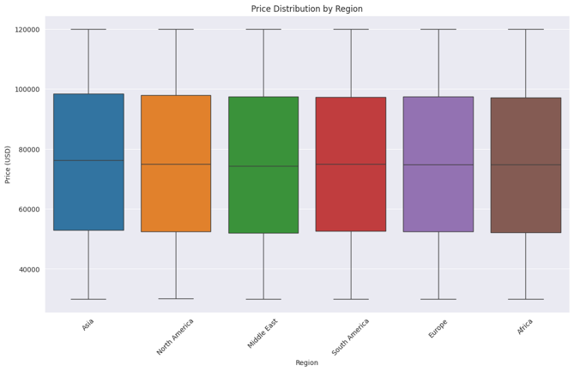

Graph 5: Heatmap - Correlation Analysis
- What it Shows: This heatmap visualizes the pairwise correlation coefficients between the numerical variables (Engine_Size_L, Mileage_KM, Price_USD, and Sales_Volume).
- Justification: A heatmap was used to quickly visualize the strength and direction of relationships between all continuous variables at once.
- Finding: The heatmap clearly showed that all correlation coefficients are extremely close to 0. This indicates no significant linear relationship exists between these key numerical variables. For example, a higher price does not correlate with higher or lower sales volume in this dataset.

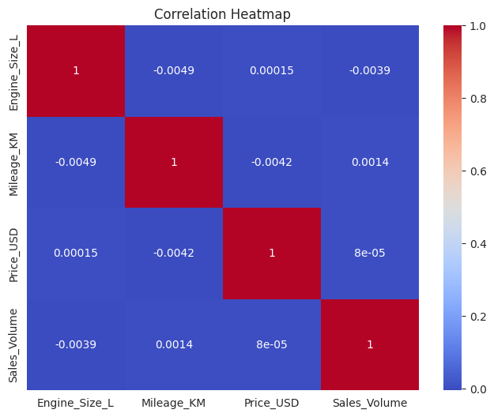

Graph 6: Line Plot - Sales Over Time
- What it Shows: This line plot displays the trend of Sales_Volume over the Year.
- Justification: A line plot is the standard and most effective visualization for time-series analysis. It was chosen to reveal trends, cyclical patterns, and long-term changes that would be missed with other chart types.
- Finding: The plot shows time-based cyclicality in sales and highlights recent growth trends.

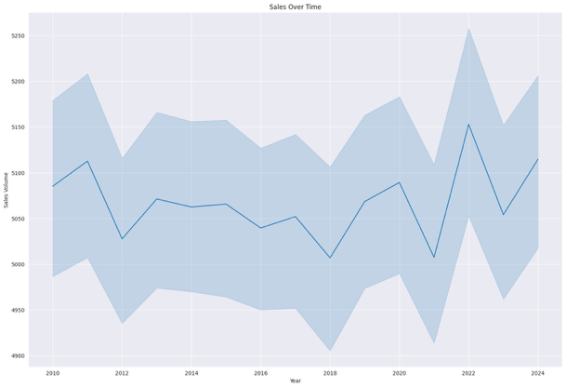

4. Hypothesis Testing
Three statistical tests were performed to draw meaningful conclusions.
- ANOVA (Price by Fuel_Type):
  - Hypothesis (Null): There is no significant difference in average vehicle price between fuel types (Petrol, Diesel, Electric).
  - Result: The p-value was 0.530. As this is greater than 0.05, we fail to reject the null hypothesis.
  - Conclusion: There is no statistically significant difference in mean prices among fuel types.
- ANOVA (Price by Region):
  - Hypothesis (Null): The average vehicle price is the same across all regions.
  - Result: The p-value was 0.426. As this is greater than 0.05, we fail to reject the null hypothesis.
  - Conclusion: The average vehicle price is statistically the same across all regions.
- Chi-Squared (Fuel vs. Transmission):
  - Hypothesis (Null): Fuel type and transmission are independent.
  - Result: The p-value was 0.659. As this is greater than 0.05, we fail to reject the null hypothesis.
  - Conclusion: There is no statistical association between a vehicle's fuel type and its transmission.

5. Business Insights & Recommendations
Based on the analysis, the following insights and recommendations were formulated.

Key Insights:
- Visual vs. Statistical: The most significant insight is the discrepancy between visual and statistical analysis. While ANOVA tests showed no significant difference in average price by region or fuel type, the boxplots clearly show visual differences in price medians and spreads. This suggests that while averages are similar, the mix of models and their price distributions vary.
- No Obvious Drivers: There are no strong linear correlations between price, mileage, engine size, or sales volume.
- Market Independence: Fuel type and transmission choice are not statistically linked, suggesting customers do not strongly associate one with the other.
- Market Performance: Sales volumes vary significantly by model and region, and sales follow clear cyclical patterns over time.

Actionable Recommendations:
- Test Targeted Regional Pricing: Despite the ANOVA results, the visual differences in price medians and spreads from the boxplot (Graph 4) are compelling. This suggests that a uniform pricing strategy is not optimal. It is recommended to test targeted regional pricing strategies to optimize profits based on these observed market differences.
- Focus Marketing on Proven Performers: Use the "Volume of Sales By Model" (Graph 1) and "Sales by Region" (Graph 3) plots to identify and promote top-selling models in high-volume regions that also show recent growth.
- Manage Inventory Using Time-Series Data: Actively monitor the cyclical sales patterns identified in the "Sales Over Time" (Graph 6) plot. This trend data should be used to manage inventory, prevent stockouts, and plan promotions to align with seasonal demand.

---END OF REPORT---

